# HM20/HM15/HM10-H Inverter User Manual

V240518

|  |  |  |
| --- | --- | --- |
| 日期 | 更新说明 | 编制人 |
| 20240425 | 初版 | 肖巧云 |
| 20240518 | 1. 适用产品变更为HM20\HM15\HM10-H 2. 修改参数表 3. 增加CT连接方式 4. 优化安装细节 | 肖巧云 |
|  |  |  |
|  |  |  |
|  |  |  |
|  |  |  |
|  |  |  |

Contents

[1. Company Overview 5](#_Toc18383)

[2. Precautions 6](#_Toc15097)

[2.1. General Statement 6](#_Toc23464)

[2.2. Safe Transportation and Storage 7](#_Toc25159)

[2.3. Important Safety Information 8](#_Toc20184)

[2.4. Installer Requirements 11](#_Toc6287)

[2.5. Safety Symbols Description 12](#_Toc6936)

[2.6. System Maintenance Information 13](#_Toc2718)

[3. Product Introduction 14](#_Toc21529)

[3.1. Inverter Parameters 14](#_Toc30510)

[3.2. Dimensions 19](#_Toc30799)

[3.3. Port Descriptions 20](#_Toc15103)

[3.4. System Model Introduction 21](#_Toc20777)

[3.5. Application scenarios 23](#_Toc8871)

[4. Preparation Before Installation 26](#_Toc9768)

[4.1. Packing List 26](#_Toc22501)

[4.2. Selection of the Installation Environment 32](#_Toc24932)

[4.3. Selection of Installation Location 33](#_Toc11894)

[4.4. Preparation of Installation Tools 34](#_Toc31105)

[5. Installation 35](#_Toc29896)

[5.1. Floor-Mounted Installation 35](#_Toc21552)

[5.2. Wall-Mounted Installation 41](#_Toc20213)

[6. Wiring 44](#_Toc11677)

[6.1. Grounding Connection 44](#_Toc5872)

[6.2. Load Connection 44](#_Toc13445)

[6.3. Generator (GED) Connection 47](#_Toc21199)

[6.4. Grid Connection 48](#_Toc18375)

[6.5. PV Connection 50](#_Toc6794)

[6.6.COM (Communitcation) Port Connection 53](#_Toc27052)

[6.7. RJ45 Port Connection 56](#_Toc20662)

[6.8. Meter Connection(Optional) 58](#_Toc24120)

[6.9. CT Installation 61](#_Toc28156)

[6.10. DRM Connection 62](#_Toc21830)

[6.11. Communication Dongle Connection (Optional) 63](#_Toc23897)

[7. System Operation 63](#_Toc17979)

[7.1. Power On 63](#_Toc6006)

[7.2. Power Off 65](#_Toc4753)

[7.3. Precautions 65](#_Toc23952)

[8. LED Display Description 66](#_Toc28047)

[8.1. Inverter LED Display 66](#_Toc14537)

[8.2. Distribution Box LED Display 68](#_Toc15079)

# Company Overview

Established in 2018, ESY SUNHOME swiftly gained prominence as a leading player in the energy storage industry, specializing in lithium battery technology and Battery Management Systems (BMS). Backed by cutting-edge protection systems and a dedicated R&D team, the company earned recognition for its innovative solutions. These advancements culminated in the development of the HM series All-in-One residential Energy Storage systems, distinguished by their advanced AI functionalities and robust IP66 waterproof and dust-proof ratings, ensuring unparalleled reliability and easy installation in any setting.

With branches strategically located in Sydney, Australia, and Munich, Germany, ESY SUNHOME is positioned for global expansion, with aspirations to establish a significant international presence. The company's steadfast commitment to democratizing clean energy underscores its mission, empowering communities worldwide to embrace sustainability for a brighter future.

Mission:To provide safe and high quality new energy products (batteries and power supplies) for every family.

Vision：Make Clean Energy Available to Every Family.

Core Values:

* Collaborative Spirit
* Down-to-Earth Practicality
* Forward-thinking Innovation
* Rigorous Scientific Craftsmanship
* Delivering Value for Clients
* Making a Positive lmpact on Society

# Precautions

## General statement

This manual is applicable for the installation, maintenance and repair of HM20 ENERGY STORAGE SYSTEM/HM15 ENERGY STORAGE SYSTEM/HM10-H ENERGY STORAGE SYSTEM. Please retain this manual properly, and strictly follow all safety instructions and operational instructions contained herein.

ESY SUNHOME bears no responsibility for any consequences arising from failure to comply with the general safety requirements or safety standards for design, production, and use.

It is crucial to use this product under specified design conditions. Any damage to components, personal injury, or property loss resulting from improper use will not be covered under warranty.

During installation, use, and maintenance, adherence to all local laws and regulations is mandatory. The safety instructions provided in this manual are supplementary to local laws and regulations.

The content in this manual will undergo periodic review and updates as needed. ESY SUNHOME reserves the right to make improvements or changes to the products and procedures described in this manual at any time without prior notice.

The product diagram in this manual are used for illustrative purpose only. The product models depicted in the illustrations may differ from the actual product.

The circuit diagrams in this manual are used for illustrative purpose only. Actual installation may be adjusted according to the local requirements and application scenarios.s

Some products, accessories, functions, and services mentioned in this manual are optional items and may not be within your use scope.

For further details, please consult authorized personnel or organizations of ESY SUNHOME.

ESY SUNHOME reserves all rights to the final interpretation in this document.

## Safe Transportation and Storage

During transportation of the inverter, it is essential to utilize the original packaging to ensure the safety of the equipment throughout the shipping process.

Upon receiving the shipments, please thoroughly inspect the external packaging of the inverter before opening the box for a comprehensive inspection.

If any damage to the inverter occurs during transportation, please notify the shipping company immediately. The shipping company is responsible for any equipment damage incurred during transit. If necessary, seek assistance from the installation personnel or manufacturer.

When handling inverters weighing 35 kg or more, please use appropriate equipment or collaborate with multiple individuals for safe handling.

When storing the equipment, please use the original packaging and store it in a cool, dry, and well-ventilated area to prevent damage from moisture.

## Important Safety Information

Before installing, operating, and maintaining the equipment, please read this manual carefully

Make sure that the product is adequately grounded before operation. The grounding resistance should be less than 0.1Ω.

Install all terminals of the energy storage system in accordance with the instructions provided in this manual. Follow the corresponding signs and symbols on the equipment during operation.

During installation, please use the accessories provided in the product packaging.

During maintenance, the maintenance personnel are prohibited from operating any equipment until all equipment has been shut down and completely discharged.

The battery terminal may be live during operation. If the battery is disconnected, please apply pearl wool inside the protective cover as a protective measure.

To ensure that the electrical parameters match requirements, relevant measuring equipment is required during system connection and testing. Ensure that the specifications of the equipment match to prevent arcing or impact.

During instruction, maintenance and repair, warning signs shall be set up in the operational area of the system to prevent accidents caused by unauthorized personnel.

Before installation, maintenance, or repair, use professional equipment to measure the voltage of the inverter and battery terminals to prevent injury to operators from energized ports.

|  |  |
| --- | --- |
|  | **Danger!** |
| Unauthorized removal, improper use, or incorrect installation or operation may result in serious personal injury or equipment damage. Therefore, transportation, installation, startup, dismantling, and maintenance must be carried out by qualified or trained personnel. |
|  | **Danger!** |
| Before undertaking any repair, electrical installation, or accessing any live parts, make sure that the inverter is cut off and wait for 5 minutes until internal capacitors are discharged to a safe voltage. |
|  | **Danger!** |
| Do not connect the neutral (N) line of the load to the grid, or connect the grid cable to the output terminal of the load. Doing so may result in serious damage to the product and load. |
|  | **Danger!** |
| The external CT must be connected to the inverter properly and securely before use. Failure to do so may result in high voltage at the CT ports. |
|  | **Warning!** |
| Installation must fully comply with national and local laws and regulations. |
|  | **Warning!** |
| Due to the non-isolated topology is applied on the PV and grid side of the inverter, please use monocrystalline or polycrystalline silicon solar panels (the negative PV pole must not be grounded). |
|  | **Warning!** |
| When exposed to sunlight, the PV array will generate a high DC voltage. For installation safety, please make sure that the entire PV panel is covered with an opaque cover before connection. |
|  | **Warning!** |
| Ensure that the input voltage at the photovoltaic ports of the inverter never exceeds the maximum value. Exceeding the maximum voltage may result in permanent damage to the inverter or other losses, [please consider the influence of temperature; the voltage of photovoltaic modules at -20℃ in winter is about 15% higher than at 30℃ in summer.]. Do not connect any power source other than the PV module at the PV input port. |
|  | **Warning!** |
| Unauthorized replacement of the internal circuitry of the inverter is prohibited. |
|  | **Warning!** |
| Before connecting to the grid, the product must be securely grounded. Please follow the instructions in this manual. Improper operation may cause serious damage. |
|  | **Warning!** |
| Please ensure that a lightning protection device is installed in the power distribution box. |

## Installer Requirements

The operators should be professionally qualified or trained.

The operators should be familiar with the entire storage system, including its components and operating principles.

The operators should be familiar with the product instruction.

The grid-connected electricity selling of the energy storage system must be approved by the local power authority, or compliant with the relevant provisions of national and local laws and regulations. It must be conducted by qualified personnel.

## Safety Symbols Description

The symbols that may be found in this product are defined as follows.

|  |  |
| --- | --- |
| **MODEL:ESYSUNHOME HM20** | ESY SUNHOME: Brand Name HM20: Model, indicating that the inverter specification is 20kW. |
|  | Pay attention to safety. |
|  | Attention: High surface temperature. |
|  | Caution: Risk of electric shock. |
|  | Prior to attempting any repair, electrical installation, or accessing any live parts, make sure that the inverter is switched off and wait for 5 minutes until internal capacitors are discharged to a safe voltage. |
|  | Professional recycling and reuse are required. |
|  | Please read this manual before using the product. |
|  | Compliant with CE safety certification standards. |

## System maintenance information

To ensure reliable and long-term service of the system,shut down the system monthly and check the following items:

Ensure that the equipment surface is free of excessive dust.

Ensure the equipment is in a non-humid environment.

Ensure that the inverter buzzer rings when the system is powered on again.

# Product Introduction

## Inverter Parameters

|  |  |  |  |
| --- | --- | --- | --- |
| MODEL | HM10-H | HM15 | HM20 |
| PV input | | | |
| Max. input power | 20 kW | 30 kW | 30 kW |
| Rated input voltage | 650 Vd.c. | | |
| Max.input voltage | 1000 Vd.c. | | |
| MPPT voltage range | 160 ~ 1000 Vd.c.c | | |
| Min. operating voltage | 160 Vd.c. | | |
| Starting voltage | 180 Vd.c. | | |
| Max. input current | 16 A/16 A | 16 A/32 A | |
| Max. Short-circuit current | 24 A/24 A | 24 A/48 A | 24 A/48 A |
| MPPT Quantity | 2 | | |
| PV input backfeed short circuit current | 0 Ad.c. | | |
| Battery input/output rating | | | |
| Battery type | IFpP/Lithium lron Phosphate | | |
| Rated voltage | 450 Vd.c. | | |
| Grid charging | YES | | |
| Battery voltage range | 150 Vd.c. ~ 600 Vd.c. | | |
| Max.charging power | 10 kW | 15 kW | 20 kW |
| Max. charging current | 25 Ad.c. | 37.5 Ad.c. | 50 Ad.c. |
| Max. discharging power | 10 kW | 15 kW | 20 kW |
| Max. discharging current | 25 Ad.c. | 37.5 Ad.c. | 50 Ad.c. |
| Battery output short circuit current | 80 A | | |
| Battery input backfeed short circuit current | 80 A | | |
| Grid rating | | | |
| Rated voltage | 400 Va.c. 3L/N/PE | | |
| Rated frequency | 50 / 60 Hz | | |
| Rated input/output power | 10 kW | 15 kW | 20 kW |
| Rated apparent power | 10 kVA | 15 kVA | 20 kVA |
| Max. input apparent power | 15 kVA | 22.5 kVA | 30 kVA |
| Max.output apparent power | 11kVA | 16.5kVA | 22kVA |
| Rated input/output current | 14.4 A@ 400 Va.c. | 21.7A@ 400 Va.c. | 29.0 Aa.c. @ 400 Va.c. |
| Max. input current | 21.7 A@ 400Va.c. | 32.6 A@ 400Va.c. | 40 Aa.c. @ 400 Va.c. |
| Max. output current | 15.8 A@ 400Va.c. | 23.8 A@ 400Va.c. | 31.8 Aa.c. @ 400 Va.c. |
| Power factor range | 0.8 leading~0.8 lagging | | |
| THDI(@Range power) | ≤ 3% | | |
| Max. output fault current | / | / | / |
| Max. output over current protection | 95 A | | |
| Grid port inrush current | / | | |
| Grid Mains output short circuit current | 260 A | | |
| Grid input backfeed short circuit current | 260 A | | |
| Backup load output rating | | | |
| Rated output voltage | 400 Va.c. 3L/N/PE | | |
| Rated output frequency | 50 / 60 Hz | | |
| Rated output power | 10 kW | 15 kW | 20 kW |
| Max. apparent output power | 10 kVA | 15 kVA | 20 kVA |
| Max. output current | 14.4 A@ 400 Va.c. | 21.7 A@ 400 Va.c. | 29.0 Aa.c. @ 400 Va.c. |
| THDV | ≤ 3%（linear load） | | |
| Overload capacity | 105%, 60S/120%, 30S | | |
| Switching time | ≤ 10 ms | | |
| Load output short circuit current | 260 A | | |
| Generator input | | | |
| Max. input power | 10 kW | 15 kW | 20 kW |
| Max. input current | 14.4 A@ 400 Va.c. | 21.7 A@ 400 Va.c. | 29.0 Aa.c. @ 400 Va.c. |
| Efficiency | | | |
| Max. efficiency（PV to Grid） | 98.2% | | |
| MPPT efficiency | 99.9% | | |
| General parameter | | | |
| Dimensions (LxWxH) | 660 mm×690 mm×270 mm | | |
| Net weight | / | 57.4kg | |
| Gross weight | / | 51.2kg | |
| Install method | Floor mounting/ Wall mounting | | |
| Ambient temperature range | -25 ~ 60℃ | | |
| Storage temperature | -25~70 ℃ | | |
| Altitude | ≤ 3000 m | | |
| Noise level at 1m | ≤ 45dB | | |
| Relative humidity | 5~95% | | |
| Cooling method | Natural cooling | Intelligent air cooling | |
| Environmental category | Outdoor | | |
| Environment pollution degree | External: PD 3, Internal: PD 2 | | |
| Communication method | WiFi/Ethernet/GPRS (optional), USB/RS485/CAN | | |
| Ingress protection rating | IP 66 | | |
| Protection rating | Class I | | |
| Anti-islanding method | Active anti-islanding: Power Variation (method c) | | |
| Topology | Non isolated | | |
| Over voltage category | OVC Il (for PV/Battery);  OVC Ill (for AC Gird Mains) | | |
| 保护  Protection | over/under-voltage;  over/under-frequency;  overload;  short circuit;  over-temperature;  reverse polarity of PV module and battery;  leakage current;  Insulation resistance;  anti-island protection | | |
| Warranty | 120 Months | | |
| Country of Manufacture | China | | |
| Certification& Standard | | | |
| Grid Regulation | VDE 0126, EN50549, DIN VDE V 0124-100:2020, VDE-AR-N 4105: 2018 | | |
| Safety Regulation | IEC/EN 62109-1/-2, AS62109 | | |
| EMC | IEC/EN 61000-6-1/-2/-3/-4 | | |

## Dimensions

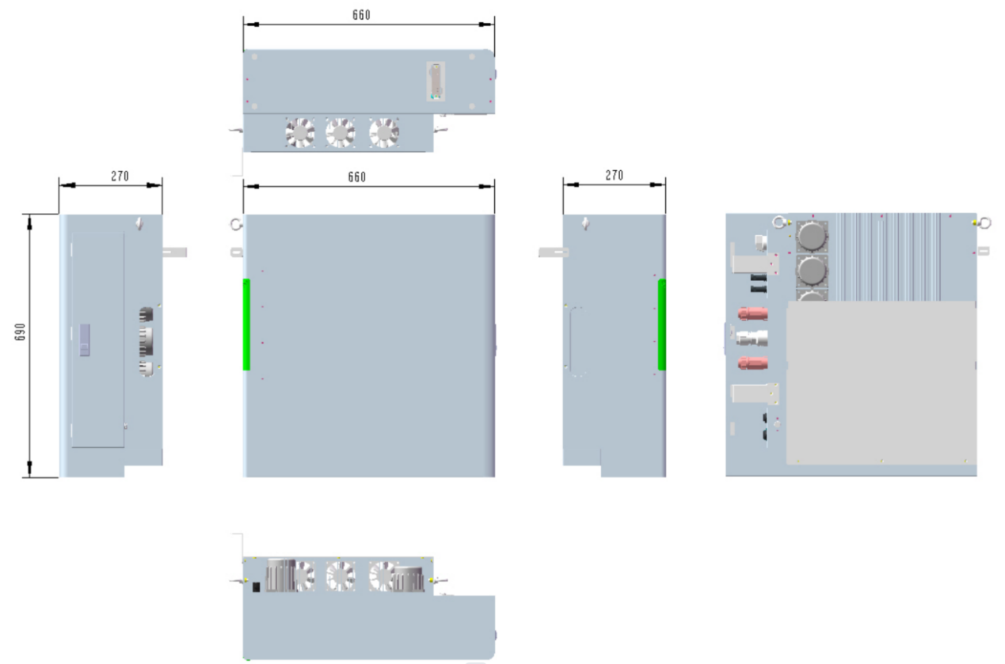（Dimensions to be updated）

## Port Descriptions



（Pictures to be updated）

|  |  |  |
| --- | --- | --- |
| Purpose of each port on the inverter enclosure | | |
| S/N | Mark | Purpose |
| 1 | DC SWITCH | PV OFF/ON Switch |
| 2 | PV1- | Negative PV1 terminal connection |
| 3 | PV1+ | Positive PV1 terminal connection |
| 4 | PV2- | Negative PV2 terminal connection |
| 5 | PV2+ | Positive PV2 terminal connection |
| 6 | GED | Generator terminal connection |
| 7 | GRID | Grid connection |
| 8 | LOAD | Load connection |
| 9 | WIFI | WiFi-IoT Max port (optional) |
| 10 | COM | Communication port connection |
| 11 | PARALLEL IN | Parallel in port (Reserved) |
| 12 | PARALLEL OUT | Parallel out port (Reserved) |
| 13 | USB | USB port |
| 14 | DRM | DRM port (for Australia) |
| 15 | CT/METER | CT/METER port |

## System Model Introduction

|  |  |
| --- | --- |
|  | **Warning!** |
| When stacking batteries for HM20/HM15/HM10-H inverter, please use the specified model of distribution box, batteries, and accessories. |

|  |  |  |  |  |  |
| --- | --- | --- | --- | --- | --- |
| Battery Capacity | Quantity of items required when installing batteries of different capacities : | | | | |
| HM20 Inverter | 10KWH+H Battery | 10KWH+H  Distribution Box | 10KWH+H  Cover | 10KWH+H  Battery Base |
| 10 kWh | 1 | 1 | 1 | 0 | 1 |
| 20 kWh | 1 | 2 | 1 | 0 | 1 |
| 30 kWh | 1 | 3 | 1 | 0 | 1 |
| 40 kWh | 1 | 4 | 2 | 1 | 2 |
| 50 kWh | 1 | 5 | 2 | 1 | 2 |
| 60 kWh | 1 | 6 | 2 | 1 | 2 |
| 70 kWh | 1 | 7 | 3 | 2 | 3 |
| 80 kWh | 1 | 8 | 3 | 2 | 3 |
| 90kWh | 1 | 9 | 3 | 2 | 3 |

|  |  |  |
| --- | --- | --- |
| Appearance of different system models: | | |
| HM10-H-20 | HM15-20 | HM20-20 |
| HM20-20 | HM20-20 | HM20-20 |
| HM10-H-20 | HM15-20 | HM20-20 |
| HM20-30 | HM20-30 | HM20-30 |
| HM10-H-40 | HM15-40 | HM20-40 |
|  |  |  |
| HM10-H-50 | HM15-50 | HM20-50 |
|  |  |  |
| HM10-H-60 | HM15-60 | HM20-60 |
| HM20-60 | HM20-60 | HM20-60 |
| HM10-H-70 | HM15-70 | HM20-70 |
|  |  |  |
| HM10-H-80 | HM15-80 | HM20-80 |
|  |  |  |
| HM10-H-90 | HM15-90 | HM20-90 |
| HM20-90 | HM20-90 | HM20-90 |

## Application Scenarios

### Used as A Photovoltaic(PV) Inverter

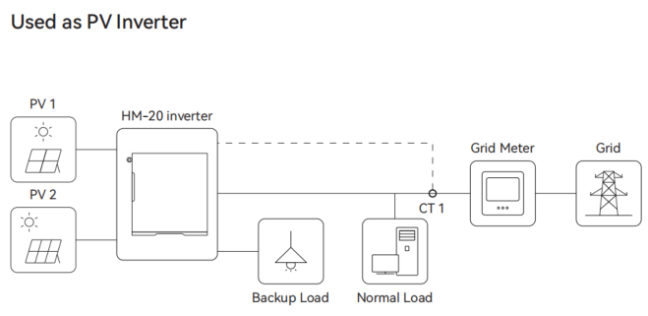

### DC-Coupled Storage System

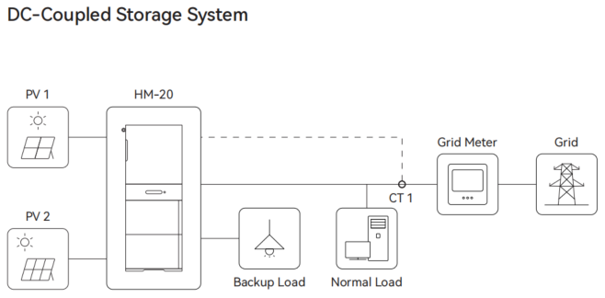

### AC-Coupled Storage System

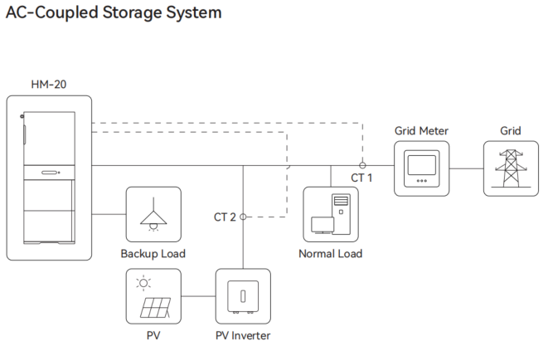

### Hybrid-Coupled Storage System

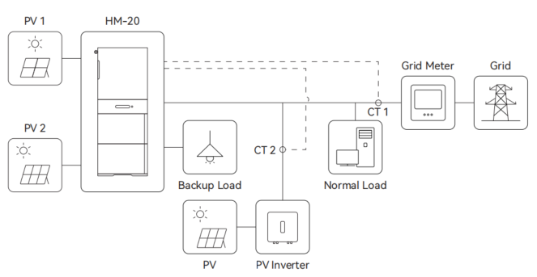

### Micro Grid Storage System

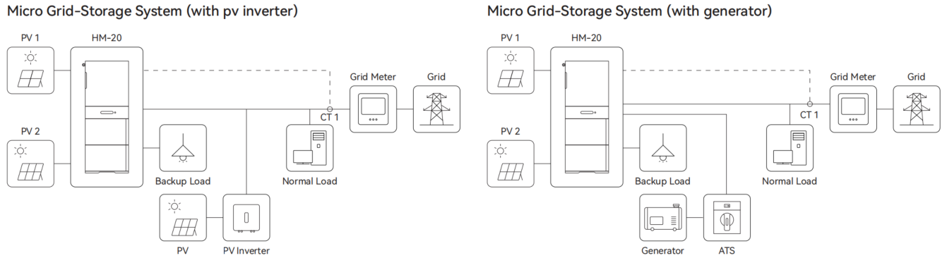

### Parallel Mode

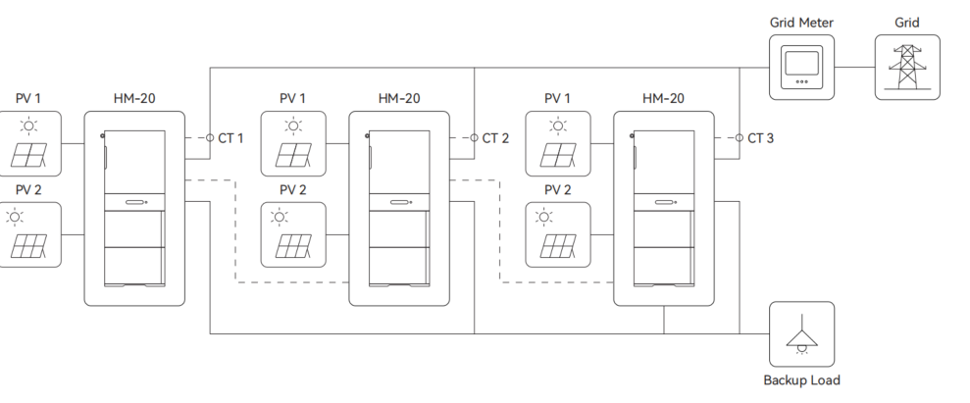

# Preparation Before Installation

## Packing List

### Packing List of Inverter

|  |  |  |  |
| --- | --- | --- | --- |
| Item | Specifications | Quantity | Schematic Diagram |
| 逆变器  Inverter | HM20/HM15/HM10-H | 1 | IMG_256 |
| PV+ Connector | VP-D4B-CHSM4 external terminal casing, including metal terminal | 3 |  |
| PV- Connector | VP-D4B-CHSF4 internal terminal casing, including metal terminal | 3 |  |
| LAN Port Connector | RJ45, assembly-type;  Line diameter φ3.0 mm-φ6.0 mm | 4 |  |
| COM Port Connector | 16 Pin, core diameterφ0.5-0.75mm² | 1 |  |
| COM Port Waterproof Ring | External diameter Φ18.6 mm;  Line diameter φ4-6.1 mm, 4 holes | 1 |  |
| COM Port Nylon Screw Plug | Diameterφ5 mm, height 17 mm | 4 |  |
| Load Output Terminal | RBH100-32-5P-W-M-26-BK | 1 |  |
| Generator Port Connector | RBH100-32-5P-W-F-26-BK | 1 |  |
| Grid Port Connector | AC5C Connector I 5PCF | 1 |  |
| Connector Removal Tool | Used for Load/Generator/Grid port connector | 1 |  |
| Insulated Cord End Terminal 4mm² | E4012, orange, used for load/generator port connector | 20 |  |
| Insulated Cord End Terminal 6mm² | E6010, orange, used for grid port connector | 10 |  |
| Insulated Cord End Terminal 0.75mm² | E7512, red, used for COM port connector | 16 |  |
| Angle Iron | L79.5×65×25mm | 1 | IMG_256 |
| Expansion Tubes with Screws | M6×40 mm, used for angle iron | 1 |  |
| Angle Iron Screws | M4×12 mm | 1 |  |
| Ring-Shaped Crimp Cable lug | RNB5.5-6, 48A, Φ=6.5 mm, 5.6×23 mm | 1 |  |
| Ground Wire Screw | M6×12 mm | 1 |  |
| Smart Dongle (Optional) | WiFi IoT Max | 1 | 捕获 |
| Smart Electricity Meter (Optional) | DTSD3366M-4-W1-A, CT\*6pcs, 1-to-3\*2pcs adapters | 1 | IMG_256 |
| Electricity Meter Guide Rail (Optional) | T=1.0 mm, 35\*7.5\*80 mm | 1 |  |
| Expansion Tubes with Screws (Optional) | M6×40 mm, used for Smart electricity meter | 2 |  |
| CTs Components (Optional) | CT\*3 with cable and RJ45 terminal | 1 |  |

### Packing List of Distribution Box & Base

Suitable for floor-mounted installation mode.

|  |  |  |  |
| --- | --- | --- | --- |
| Item | Specifications | Quantity | Schematic Diagram |
| Distribution Box | 10KWH+H Distribution Box | 1 |  |
| LAN Port Connector | RJ45, assembly-type;  Line diameter φ3.0 mm-φ6.0 mm | 3 |  |
| Key | Triangular lock hole | 2 |  |
| Handlebar Screws | M4\*35mm | 4 |  |
| Waterproof Connector Cover | Silicone, black, matte, 104.5x50.3x10.6 mm | 2 |  |
| Base | 10KWH+H Battery Base | 1 |  |
| Base Mounting Screws | M4×10 mm | 4 |  |
| Smart Communication Dongle (Optional) | WiFi IoT Max | 1 | 捕获 |

### Packing List of Battery

Suitable for floor-mounted installation.

|  |  |  |  |
| --- | --- | --- | --- |
| Item | Specifications | Quantity | Schematic Diagram |
| Battery | 10KWH+H Battery | 1 |  |
| Angle Iron | L79.5×65×25 mm | 2 |  |
| Handlebar Screws | M4×35 mm | 4 |  |
| Angle Iron Screws | M4×8 mm | 2 |  |
| Waterproof Gasket for Connector | Silicone, black, matte, 104.5x50.3x10.6 mm | 1 |  |
| Expansion Tubes Screws | M6×40 mm, Used for Angle Iron | 2 |  |
| Expansion Screw Gaskets | Inner diameterφ5 mm;  Outer diameterφ12 mm, SUS304 gasket | 2 |  |

### Packing List of Cover

Suitable for multiple sets of battery energy storage system in parallel, and suitable for floor-mounted installation.

|  |  |  |  |
| --- | --- | --- | --- |
| Item | Specifications | Quantity | Schematic Diagram |
| Cover | 10KWH+H Distribution Box Cover | 1 |  |
| Positive Connection Cable for Battery Parallel | 3 AWG, orange, length: 1600 mm | 2 |  |
| Negative Connection Cable for Battery Parallel | 3 AWG, black, length: 1600 mm | 2 |  |

### Packing List of Wall Mounting Accessories

Only applicable for wall-mount installation.

|  |  |  |  |
| --- | --- | --- | --- |
| Item | Specifications | Quantity | Schematic Diagram |
| Triangular Bracket | 340 mm×280 mm×35 mm | 2 |  |
| Bracket Base | 660 mm×170 mm×45 mm | 1 |  |
| Bracket Screws | M6×169, SUS304 | 12 |  |
| Bracket Base Screws | M5×12, SUS304 | 4 |  |
| Expansion Bolt | YPm6X70 mm, SUS304 | 12 | bcece6d7-92d1-4e29-80ec-633284c02f3f |
| Handlebar Screws | M4×35 mm | 4 |  |
| Rear Panel | 510 mm×112 mm×42.5 mm | 1 |  |
| Rear Panel Bracket | 140 mm×60 mm×30 mm | 1 |  |
| Rear Panel Screws | M6 X 16, SUS304 | 4 |  |

## Selection of The Installation Environment

The ambient temperature range is -25 ℃ to 60 ℃, when the inverter is installed without batteries, and -20℃～55℃ when the inverter is installed with batteries.

The relative humidity should be maintained between 5% to 100% (no condensation).

It can be installed outdoors, but must not be directly exposed to sunlight.

Do not install it in damp or submerged areas.

Do not install it in areas prone to lightning strikes.

Do not install it near combustibles.

To ensure proper heat dissipation, please install it in a well-ventilated place.

For stability, the product should be installed on solid and level ground.

For stability, the product should be installed on solid and flat wall.

## Selection of Installation Location

### Selection of Wall Mounting Location

Applicable scenarios: When the inverter is used as a PV inverter.

The clearances around the inverter must not be less than the following:

|  |  |  |  |  |
| --- | --- | --- | --- | --- |
| Top | Front | Right (door side) | Left | Rear |
| 800 mm | 1000 mm | 600 mm | 300 mm | 40 mm |

For vertical installation, ensure there is no forward or backward tilting.

The wall bearing capacity shall be greater than 100 Kg.

The wall thickness should not be less than 70 mm.

### Selection of Floor Mounting Location

Applicable scenarios: When the inverter is used in the energy storage system.

The wall thickness should not be less than 40 mm.

For vertical installation, ensure there is no forward or backward tilting.

The clearances around the inverter must not be less than the following:

|  |  |  |  |  |
| --- | --- | --- | --- | --- |
| Top | Front | Right (door side) | Left | Rear |
| 800 mm | 1000 mm | 600 mm | 300 mm | 40 mm |

When the inverter is installed on the ground, the ground bearing capacity is as follows:

|  |  |  |  |
| --- | --- | --- | --- |
| Modules | HM20-10 | HM20-20 | HM20-30 |
| Weight | 168 kg | 263 kg | 358 kg |

## Preparation of Installation Tools

|  |  |  |  |
| --- | --- | --- | --- |
|  |  |  |  |
| Power drillφM6 | Marker | Tape Measuring | Hammer |
|  |  |  |  |
| Open-end wrench S=7mm | Phillips Screwdriver PH1 | Allen ScrewdriverM2 | Level |
|  |  |  |  |
| Crimping Pliers for RJ45 | Crimping Pliers for PV Terminals | Ferrule Crimping Pliers | Crimping Pliers |
|  |  |  |  |
| Stripping Pliers | Diagonal Pliers | Cable Cutting Pliers (wire cutter) | Utility Knife |
|  |  |  |  |
| Safety Gloves | Dust Mask | Goggles | Safety Boots |

# Installation

## Floor-Mounted Installation

### Base Installation

|  |  |
| --- | --- |
| Tools and accessories required for this step: | |
| Packing List of Battery | Batteries |
| Packing List of Base | 10KWH+H Battery Base, Waterproof Gasket (for Connector), Base Mounting Screws |
| Tools | Phillips Screwdriver PH1, Measuring Tape, Level |

Step 1：Remove the connector port dust cover, flip the battery over with the bottom facing up.

Step 2：Align the water-proof port of the base with the battery (Do not remove the waterproof gasket for connector on the base).

Step 3：Use the base mounting screws to tighten the base, ensuring alignment between the battery and the base.

Step 4：Place the battery, with the base installed, on a suitable surface. Ensure that the back of the battery is 40mm away from the wall.

### Batteries Installation

|  |  |
| --- | --- |
| Tools and accessories required for this step: | |
| Packing List of Battery | Batteries, Waterproof Gasket (for Connector), Handlebar Screws |
| Tools | Open-end Wrench S=7 mm |

Step 1：Place the waterproof gasket onto the connector at the top of the battery.

Step 2：Stack the batteries in sequence, tighten the handlebar screws on both sides of the batteries.

|  |  |
| --- | --- |
|  | Warning! |
| Ensure that each battery pack contains no more than 3 batteries. |

### Distribution Box Installation

|  |  |
| --- | --- |
|  | **Warning!** |
| Before completing the system installation, please check that the distribution box button is in the raised position and the distribution box switch is in the "OFF" position. |
|  | |

|  |  |
| --- | --- |
| Tools and accessories required for this step: | |
| Packing List of Battery | Handlebar Screws, Waterproof Gasket (for Connector) |
| Packing List of Distribution Box | 10KWH+H Distribution Box |
| Tools | Open-end Wrench S=7 mm |

Step 1：Place the waterproof gasket onto the connector at the top of the battery.

Step 2：Stack the distribution box on the battery, tighten the handlebar screws on both sides of the batteries.

### Inverter Installation

|  |  |
| --- | --- |
| Tools and accessories required for this step: | |
| Packing List of Distribution Box | Handlebar Screws, Waterproof Gasket (for Connector) |
| Packing List of Inverter | HM20/HM15/HM10-H |
| Tools | Open-end wrench S=7 mm |

Step 1：Place the waterproof gasket onto the connector at the top of the distribution box.

Step 2：Stack the inverter on the distribution box, tighten the handlebar screws on both sides of the distribution box.

### 角铁安装Angle Iron Installation

|  |  |
| --- | --- |
| Tools and accessories required for this step: | |
| Packing List of Battery | Angle Iron, Angle Iron Screws, Expansion Tubes with Screws, Expansion Screw Gaskets |
| Packing list of inverter | Angle Iron, Angle Iron screws, Expansion tubes with screws, Expansion screw gaskets |
| Tools | Power drillφM6, Hammer, Phillips Screwdriver PH1, Marker |

Step 1：Place the angle iron screws through the angle irons and secure the angle irons to both sides of the topmost battery, but do not tighten the screws.

Step 2：Mark the position of the angle irons holes on the wall with a marker.

Step 3：Drill the holes at the marked positions with the Power drill, and hammer the expansion tubes into the holes.

Step 4：Thread the expansion tube screws through the gaskets and angle iron holes, and secure them on the wall.

Step 5：Tighten the screws after adjusting the angle irons accordingly.

Step 6：Follow the same steps to install the inverter angle iron in the upper left corner of the inverter.

### Battery Pack Installation

|  |  |
| --- | --- |
|  | **Warning!** |
| Only applicable for installation scenarios involving more than 3 batteries. |
|  | **Warning!** |
| The spacing of the adjacent batteries packs ranges from 300mm to 600mm. |
|  | **Warning!** |
| For the battery packs without stacked inverter, the distribution box covers shall be installed. |

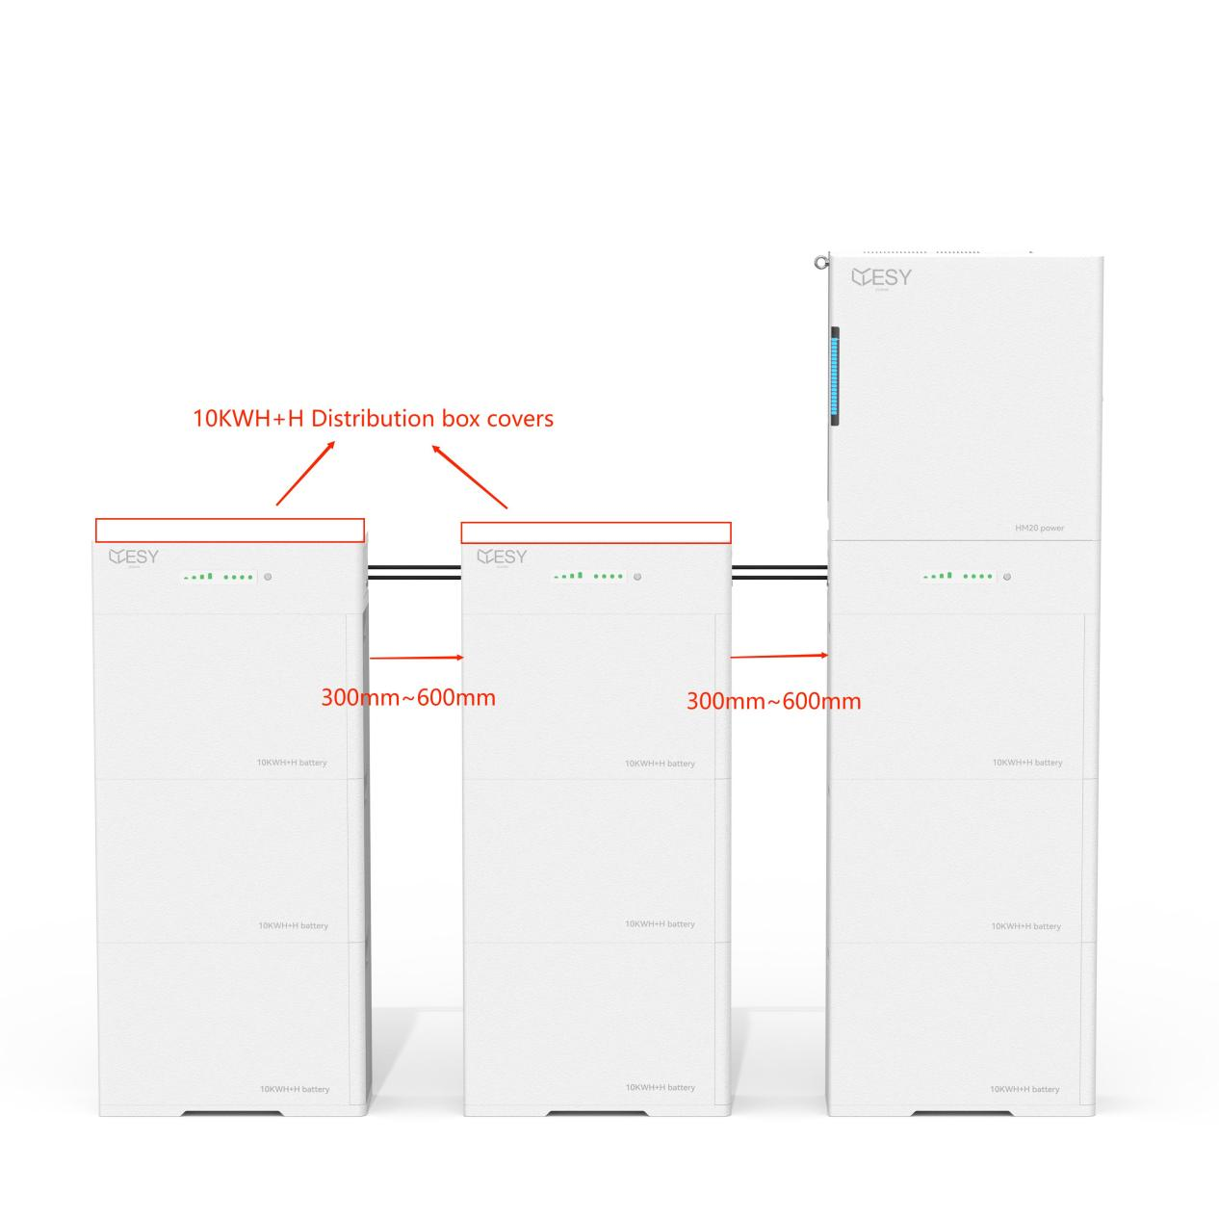

|  |  |
| --- | --- |
| Tools and accessories required for this step: | |
| Packing List of Cover | 10KWH+H Distribution box Cover, Positive Connection Cable for Battery Parallel, Negative Connection Cable for Battery Parallel. |
| Packing List of Distribution Box | Handlebar Screws, Waterproof Gasket (for Connector) |
| Tools | Hammer, Measuring Tape |

Step 1：Follow the batteries installation steps, and install the batteries packs.

Step 2：Install the waterproof gasket on the top connector of the distribution box .

Step 3：Securely place the cover on the distribution box, and tighten the handlebar screws on both sides of the distribution box.

Step 4：Remove the waterproof covers from the “ parallel +” and “parallel - ”ports of the distribution box

Step 5：Utilize the positive cluster connection cable to interconnect the parallel positive terminals of adjacent distribution boxes;

Step 6：Employ the negative cluster connection cable to link the negative terminals of adjacent distribution boxes.

|  |  |
| --- | --- |
|  | **Warning!** |
| Please retain the waterproof covers for the parallel ports of the distribution boxes. |
|  | **Warning!** |
| Please cover unused parallel ports with the waterproof covers. |

## Wall-Mounted Installation

### Positioning

|  |  |
| --- | --- |
| Tools and accessories required for this step: | |
| Packing List of Inverter | Inverter |
| Packing List of Wall Mounting Accessories | All Accessories |
| Tools | Power drillφM6, Hammer, Phillips Screwdriver PH1, Marker |

Step 1：Mark the positions of the angle irons holes on the wall with a marker.

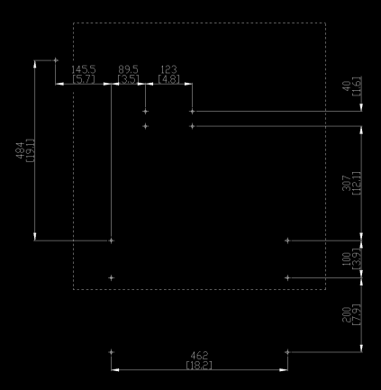

Step 2：Drill the angle iron holes with the Power drill, and hammer the expansion bolts into the holes.

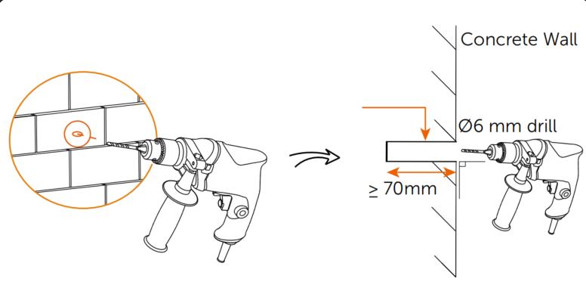

Step 3：Assemble the triangular brackets with bracket screws.

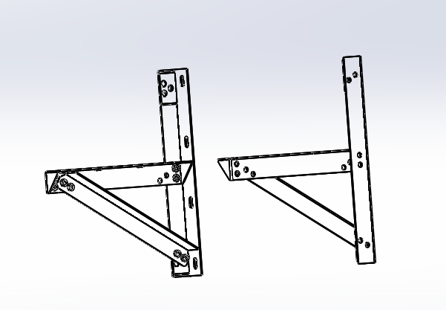

Step 4：Secure the triangular bracket and rear panel to the wall with the nuts of the expansion bolts.

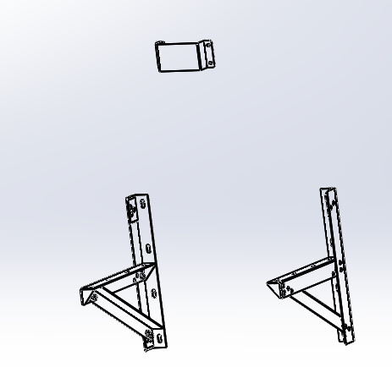

Step 5：Place the bracket base on the triangular bracket and secure it with the bracket base screws.

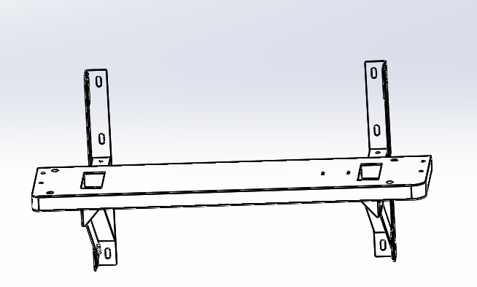

Step 6：Secure the rear panel to the heat sink of the inverter with the rear panel screws.

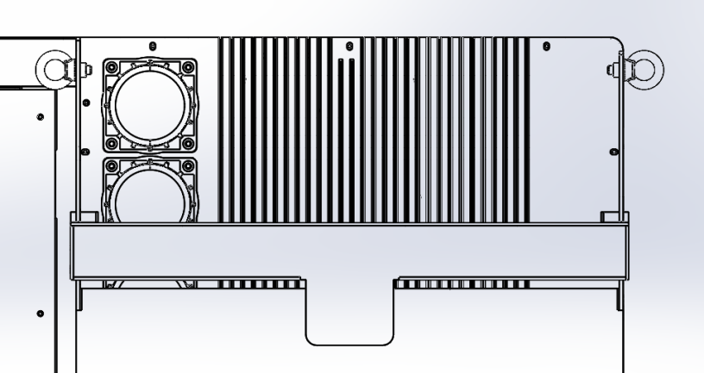

Step 7：Place the inverter on the triangular bracket and secure the inverter and bracket base with handlebar screws.

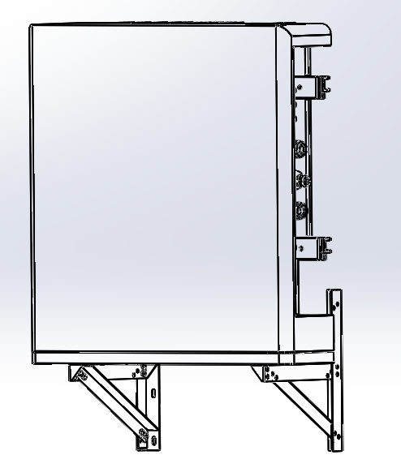

# Wiring

## Grounding Connection

|  |  |
| --- | --- |
| Tools and accessories required for this step: | |
| Packing list of inverter | Ring-Shaped Crimp Cable Lug, Ground screw |
| Tools | Crimping Pliers, Diagonal Pliers, Stripping Pliers, Phillips Screwdriver PH1, Measuring Tape |
| Cable | Ground Cableφ6mm² |

Step 1: Measure the distance between the ground wire connection aperture located on the side of the inverter and the combiner box using a measuring tape.

Step 2：Use stripping pliers to remove 4 mm of insulation from the grounding wire. Install the grounding wire terminal and crimp it tightly using crimping pliers.

Step 3：Attach the ring-shaped crimp cable lug to the right-side heat sink of the inverter using the ground wire screw.

Step 4：Properly ground the other end of the wire with a grounding impedance of 0.1 Ω or less to ensure safety in installation and operation.

## Load Connection

|  |  |
| --- | --- |
| Tools and accessories required for this step: | |
| Packing List of Inverter | Load Output Terminal, Insulated cord end terminal 4 mm², Connector removal Tool |
| Tools | Phillips Screwdriver PH1, Cable Cutting Pliers (wire cutter), Diagonal Pliers, Ferrule Crimping Pliers, Stripping Pliers |
| Cable | Five-Core Cable (copper)φ4 mm²/12 AWG |
| Breaker | Recommended Circuit Breaker Specification：40 A |

Step 1: Select an appropriate cable and use stripping pliers to remove the insulation. Use ferrule crimping pliers to crimp an insulated cord end terminal (4 mm²) onto the cable.

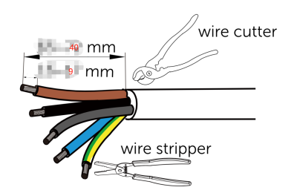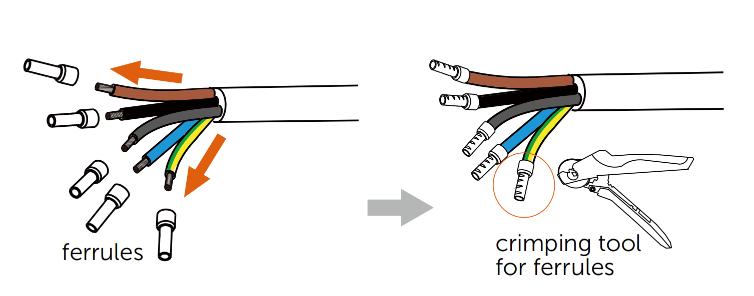

Step 2: Use the Connector removal tool to disassemble the connector, and thread the cable through the connector as shown in the diagram.

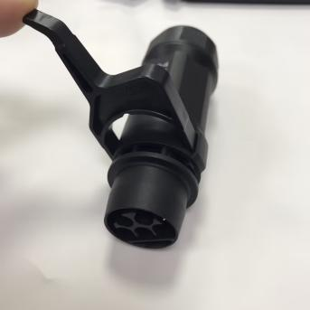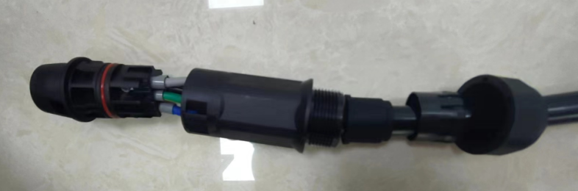

Step 3: Secure the terminal onto the connector using a Phillips screwdriver PH1.

|  |  |  |
| --- | --- | --- |
| diagrammatic | Pin | Description |
|  | 1 | R/L1 |
| 2 | S/L2 |
| 3 | TL3 |
| N | N |
|  | PE |

Step 4：Plug the connector head into the connector shell until a "click" sound is heard, it indicates that the connector is securely in place. Tighten the connector tail end nut.

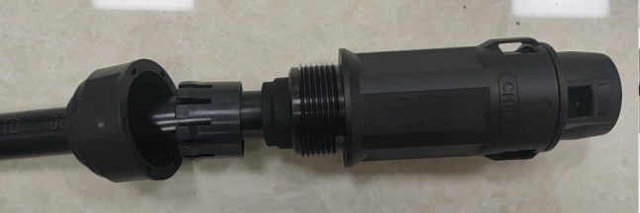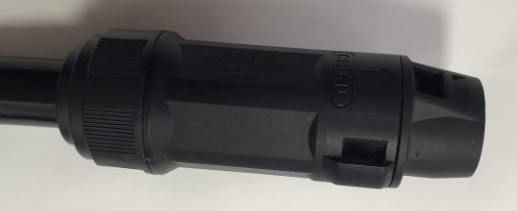

Step 5：Thread the connector through the slit of the inverter door and plug it into the LOAD port.

|  |  |  |
| --- | --- | --- |
|  | **Warning!** | |
| When removing the connector from the inverter, please use the appropriate tools. Please keep the connector removal tool properly. | |
|  | **Warning!** | |
| Please make sure to distinguish between the connector for the load port and the connector for the generator port. | |
| Load Port Connector | Generator Port Connector |
|  |  |

## Generator (GED) Connection

|  |  |
| --- | --- |
| Tools and accessories required for this step: | |
| Packing List of Inverter | Generator Port Connector, Insulated Cord End Terminal 4 mm², Connector Removal Tool |
| Tools | Phillips Screwdriver PH1, Cable Cutting Pliers (wire cutter), Diagonal Pliers, Ferrule Crimping Pliers |
| Cable | Five-Core Cable (copper)φ4 mm²/12 AWG |
| Breaker | Recommended Circuit Breaker Specification：40 A |

The steps for installing the generator port connector are the same as those for installing the load port connector.

|  |  |  |  |
| --- | --- | --- | --- |
|  | Warning! | | |
| When installing the generator, it is essential to connect the wires to the COM-6/COM-7/COM-8 terminals on the COM port connector. Please refer to the instruction manual for the installation steps of the COM port. | | |
|  | 6 | COM\_GEN\_NC |
| 7 | COM\_GEN |
| 8 | COM\_GEN\_NO |
|  | Warning! | | |
| When the GED port is connected to a generator or PV inverter, the energy storage system is in a microgrid state. Before performing any maintenance or inspection on the system, it is crucial to shut down the generator or PV inverter linked to the GED port. | | |
|  | Warning! | | |
| The generator parameters must meet the requirements of the inverter parameters and include the Automatic Transfer Switch (ATS) function. | | |
|  | Warning! | | |
| Do not connect the load to the GED port. | | |
|  | Warning! | | |
| The GED port can also be used for PV inverter connection. | | |

## Grid Connection

|  |  |
| --- | --- |
| Tools and accessories required for this step: | |
| Packing List of Inverter | Grid Port Connector, Insulated Cord End Terminal 6 mm², Connector Removal tool |
| Tools | Allen screwdriverM2, Cable cutting pliers (wire cutter), Diagonal pliers, Ferrule Crimping Pliers |
| Cable | Five-Core Cable (copper)φ6 mm²/10 AWG |
| Breaker | Recommended Circuit Breaker Specification：50 A |

Step 1：Select an appropriate cable and use stripping pliers to remove the insulation. Use ferrule crimping pliers to crimp an insulated cord end terminal 6 mm² onto the cable.

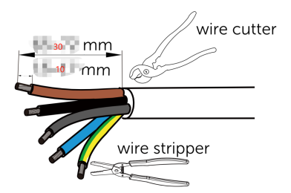

Step 2: Use the Connector removal tool to disassemble the connector, and thread the cable through the connector as shown in the diagram.

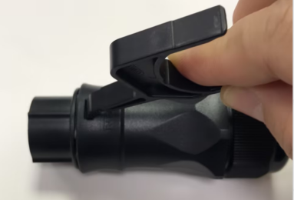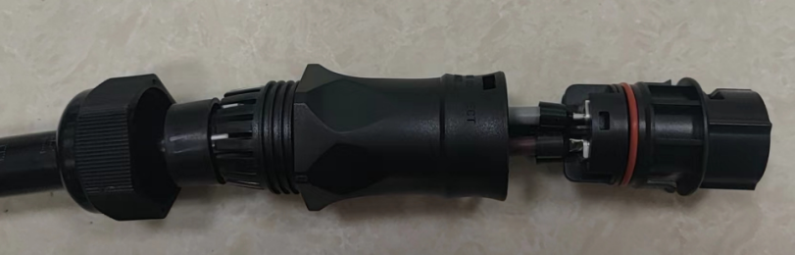

Step 3: Secure the terminal onto the connector using an Allen screwdriver M2.

|  |  |  |
| --- | --- | --- |
| Diagrammatic | Pin | Description |
|  | 1 | R/L1 |
| 2 | S/L2 |
| 3 | TL3 |
| N | N |
|  | PE |

|  |  |
| --- | --- |
|  | **Warning!** |
| When locking the power grid cable into the external grid connector, it is necessary to mark the corresponding cables with RST, because when installing the CT (Current Transformer), the three CTs with RST identifications need to be attached to the corresponding RST line. |

Step 4：Plug the connector head into the connector shell until a "click" sound is heard,indicating that the connector is securely in place. Tighten the connector tail end nut.

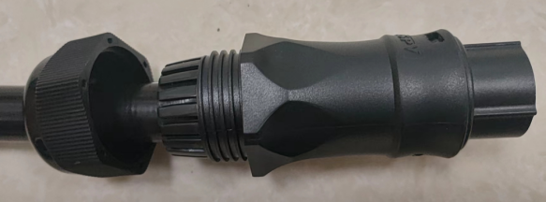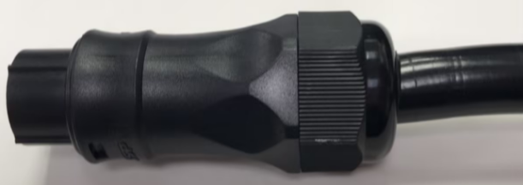

Step 5：Thread the connector through the slit of the inverter door and plug it into the Grid port.

|  |  |
| --- | --- |
|  | **Warning!** |
| When removing the connector from the inverter, please use the appropriate tools. Please keep the connector removal tool properly. |

## PV Connection

|  |  |
| --- | --- |
| Tools and accessories required for this step: | |
| Packing List of Inverter | PV- connector、PV+ Connector |
| Tools | Crimping Tool for PV Terminals、Wire cutter |
| Cables | Specialized PV Cablesφ4 mm²~6 mm² AWG 10~12 |
| Breaker |  |

Step 1：Remove 8 mm of insulation from the PV cable, and insert the exposed end of the PV cable into the PV metal pin contacts.

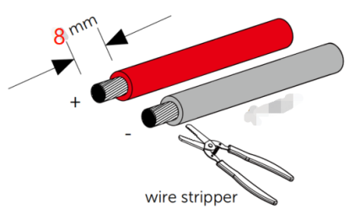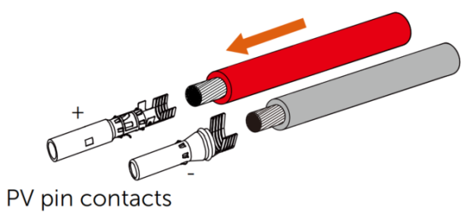

Step 2：Crimp the PV terminal securely onto the the PV cable with an MC4 crimping tool .

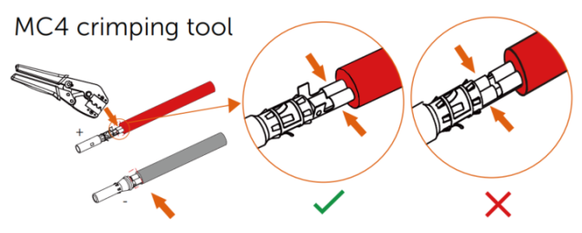

Step 3：Unscrew the connector at the rear of the PV connector slot in the PV terminals. Listen for a ‘click’ sound to confirm proper connection. Pull back on the cable to verify the terminals are securely inserted. Tighten the cover at the rear of the PV connector.

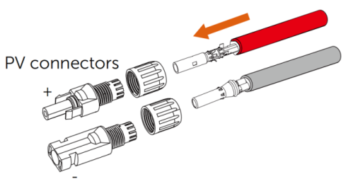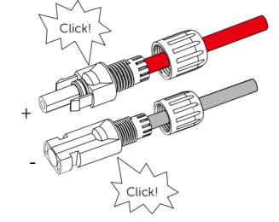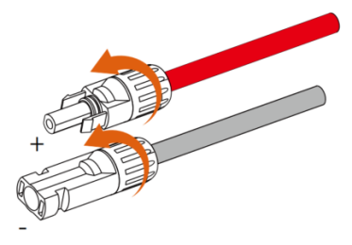

Step 4：Thread the connector through the slit of the inverter door and plug it into the PV ports.

|  |  |  |  |  |
| --- | --- | --- | --- | --- |
|  | **Warning!** | | | |
| Please ensure that the polarity of the PV cables, PV terminals, PV connectors, and PV ports of the inverter are all aligned correctly. | | | |
| Polarity | Cables | Terminals | Connectors | PV ports |
| Positive Pole + | Red |  |  |  |
| Negative Pole - | Black |  |  |  |
|  | **Warning!** | | | |
| Please use the PV connectors provided by the manufacturer. | | | |
|  | **Warning!** | | | |
| Please confirm that all PV modules are of the same type and installation angle. | | | |
|  | **Warning!** | | | |
| Please verify that the input voltage and current range of the PV modules aligned with the parameter requirements of ESY SUNHOME. | | | |
|  | **Warning!** | | | |
| PV modules must be installed by professional personnel. | | | |
|  | **Warning!** | | | |
| Once the PV modules are installed, employ a voltmeter (with a DC voltage range of 1500V or higher) to verify the polarity of the cables connecting the PV array is correct. Ensure that the open-circuit voltage does not surpass the specified value. | | | |
|  | **Warning!** | | | |
| When the ambient temperature is higher than 10°C, the open-circuit voltage of the PV array must not exceed 90% of the maximum DC voltage of the inverter. Otherwise, the voltage of the PV array may exceed the maximum input voltage of the inverter at low temperatures, which could potentially cause damage to the inverter. | | | |

## COM Connection

### COM Port Connector Pin Definitions

|  |  |  |  |
| --- | --- | --- | --- |
| COM Port Connector Pin Definitions | | | |
| Diagram | Pin Number | Definition | Instruction |
|  | 1 | RS485\_GPS\_B2 | RS485 Upper Computer Communication |
| 2 | RS485\_GPS\_A2 |
| 3 | GND\_COM | Signal Ground |
| 4 | RS485\_METER\_B | RS485 Meter Communication |
| 5 | RS485\_METER\_A |
| 6 | COM\_GEN\_NC | GEN Dry Contact (Reserved) |
| 7 | COM\_GEN |
| 8 | COM\_GEN\_NO |
| 9 | COM\_NC | COM Dry Contact (Reserved) |
| 10 | COM |

### Installation of COM Port Connector

|  |  |
| --- | --- |
|  | **Warning!** |
| Please select the appropriate cable length and quantity based on the actual installation scenario. |
|  | **Warning!** |
| Please select the correct COM port pin according to the actual installation scenario. |

|  |  |
| --- | --- |
| Tools and accessories required for this step: | |
| Packing List of Inverter | COM Port Nylon Screw Plug, COM Port Connector, Insulated Cord End Terminal 0.75 mm² |
| Tools | Ferrule Crimping Pliers, Stripping Pliers, Cable Cutting Pliers (wire cutter) |
| Cable | Multi-Strand Communication Cable, Core 0.5-0.75 mm², Cable Diameter 4-6 mm. The CAT5e network cable is recommended |

Step 1：Select the appropriate cable and strip off 12 mm of insulation using stripping pliers. Crimp insulated cord end terminal 0.75 mm² onto the cable using the ferrule crimping pliers.

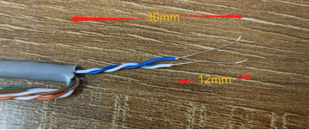 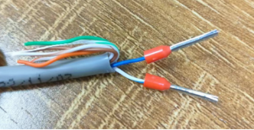

Step 2: Unscrew the nut at the connector end, and thread the cable through the connector following the diagram provided.

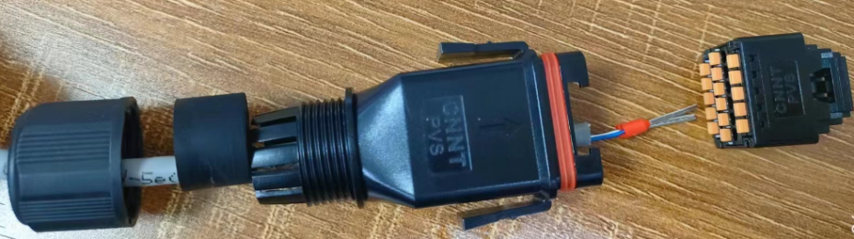

Step 3：Plug the cable terminal into the COM port connector, aligning it with the appropriate hole based on the pin definition of the COM port connector.

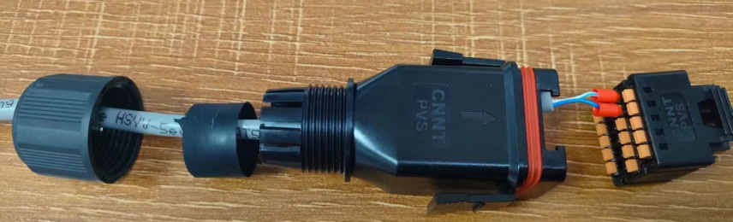

Step 4: Plug the connector head into the connector shell until a ‘click’ sound indicates it is locked in place. Seal any unused waterproof holes with the COM port nylon screw plug. Tighten the connector’s rear nut.

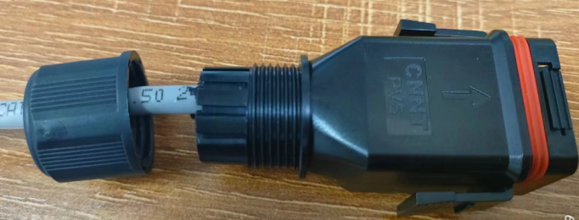 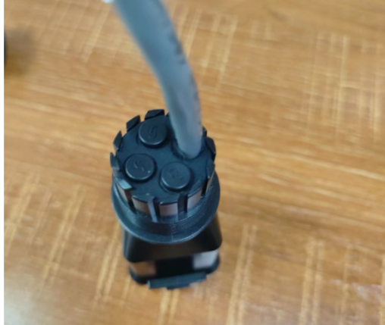

Step 5: Thread the connector through the slit of the inverter door and plug it into the COM port.

## RJ45 Port connection

### COM Port Connector Pin Definitions

|  |  |  |
| --- | --- | --- |
| CT/METER Port Connector Pin Definitions | | |
| This port can be used to connect both the electric meter and CT components. | 1 | CT\_R1 |
| 2 | CT\_S1 |
| 3 | CT\_T1 |
| 4 | METER485A |
| 5 | METER485AB |
| 6 | CT\_T2 |
| 7 | CT\_S2 |
| 8 | CT\_R2 |
| DRM Port Connector Pin Definitions | | |
| This interface is exclusively for Australian products and is designed for DRED control, applicable to Australia and New Zealand only. DRED stands for Demand Response Enabling Device. According to the AS/NZS 4777.2:2010 standard, users must support the Demand Response Mode (DRM), which is specifically for inverters meeting the RJ45 requirements outlined in the AS/NZS 4020 standard and is intended for DRMS connections. | 1 | DRM1/5 |
| 2 | DRM2/6 |
| 3 | DRM3/7 |
| 4 | DRM4/8 |
| 5 | REF GEN/0 |
| 6 | COM LOAD/0 |
| 7 | Reserved V+ |
| 8 | Reserved V- |
| Parallel In Port (Reserved) | | |
| Parallel Out Port (Reserved) | | |

### RJ45 Port Connector Pin Definitions

|  |  |
| --- | --- |
|  | **Warning!** |
| Please select the appropriate cable length and quantity based on the actual installation scenario. |

|  |  |
| --- | --- |
| Tools and accessories required for this step: | |
| Packing List of Inverter | LAN Port Connector |
| Tools | Crimping Tool for RJ45, Stripping Pliers, Wire Cutter |
| Cable | 8 strands of communication cable, core 0.5-0.75 mm², cable diameter 4-6 mm. The CAT5e network cable is recommended |

Step 1：Strip the network cable using the stripping pliers and install it through the parts as shown in the figure. Fit crystal head to the network cable according to the color sequence (1-8).

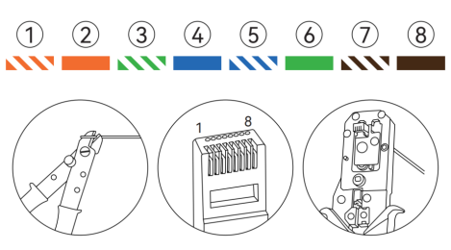

Step 2：Thread the cable through the RJ45 connector as shown in the figure.

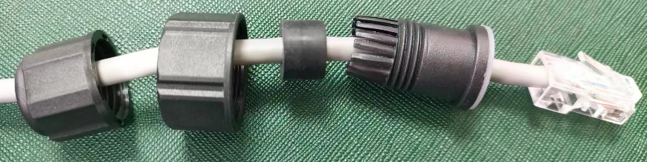

Step 3：Tighten the connector end nut.

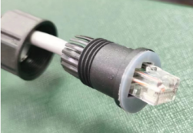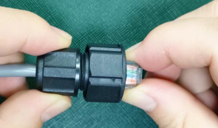

Step 4：Thread the connector through the slit of the inverter door and plug it into the correct RJ45 port.

## Meter Connection (Optional)

|  |  |
| --- | --- |
|  | Warning! |
| When using the meter, ensure to use the CT and 1-to-3 adapter provided in the meter package. The CT components equipped with RJ45 terminals are not compatible with this meter. |
|  | Warning! |
|  |

### Meter Port Descriptions

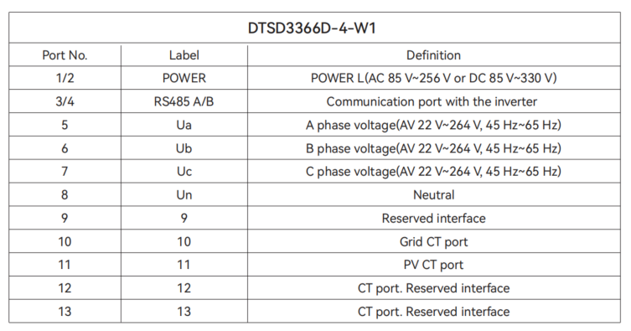

### Meter Installation

|  |  |
| --- | --- |
| Tools and accessories required for this step: | |
| Packing List of Inverter | Smart Electricity Meter (Optional), Electricity Meter Guide Rail (Optional), Expansion Tubes with Screws (Optional) |
| Tools | Power DrillφM6, Hammer, Phillips Screwdriver, Marker |
| 线缆  Cable | Communication Cable with RJ45 Connector |

Step 1：Select an appropriate location for installing the electric meter, and mark the screw holes on the DIN rail. Drill and insert the expansion tubes to secure the rail.

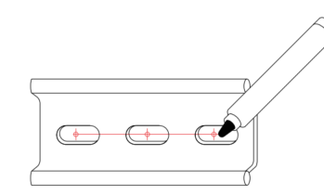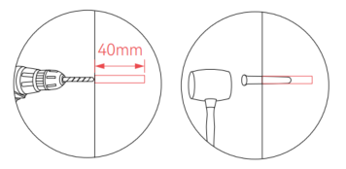

Step 2：Secure the meter onto the DIN rail provided in the inverter package (Electricity meter guide rail: DIN 35 mm).

Step 3：Attach one end of the communication cable to the RJ45 connector, and use stripping pliers to carefully remove the insulation from wires #4 and #5 on the other end.

Step 4：Connect the #4 (blue) wire to Port B of the smart meter, and the #5 (blue and white) wire to Port A. Securely tighten the screws and verify the stability of the network cable.

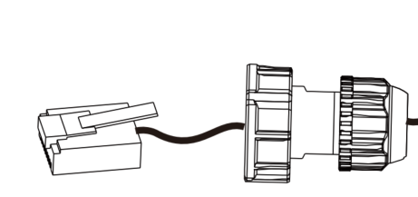 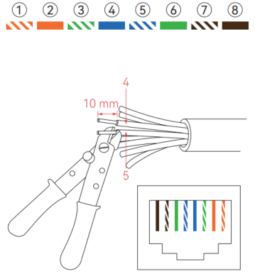 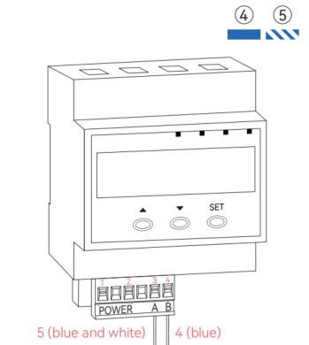

Step 5：Place the CT clamp around the live wire where current measurement is required, and secure it with cable ties.

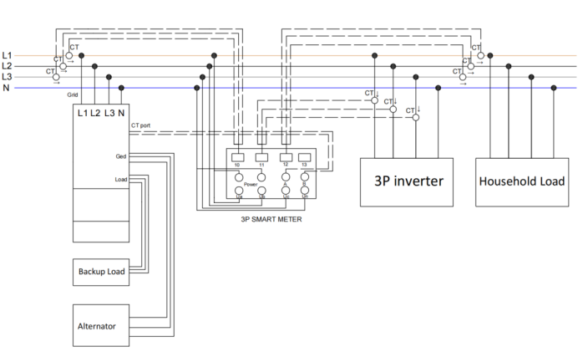

Step 6：Plug the CT terminals into the 1-to-3 adapter. Place the CT plug of phase A into the 'la' port, the CT plug phase B into the 'lb' port, and the CT plug phase C into the 'lc' port.

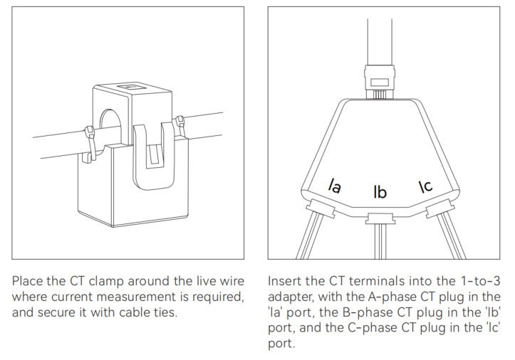

Step 7：Connect the 1-to-3 adapter to the CT ports of the smart meter.

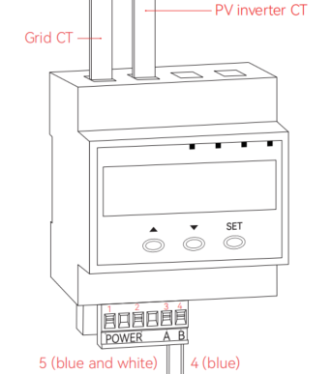

|  |  |
| --- | --- |
|  | **Warning!** |
| Please pay attention to the direction of the current flow when using the CT. |

## CT Connection

|  |  |
| --- | --- |
| Tools and accessories required for this step: | |
| Packing List of Inverter | LAN Port Connector |
| Tools | CTs Components (Optional) |

Step1：Position the CT appropriately around the grid cable, ensuring correct alignment with the current flow direction.

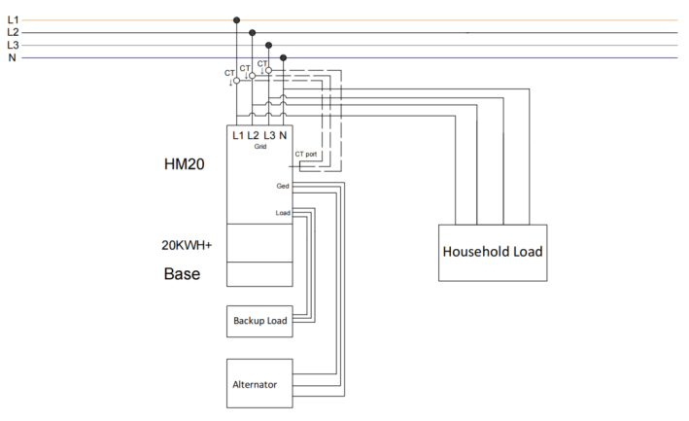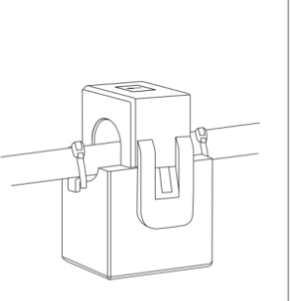

Step2：Install the RJ45 connector onto the crystal head of the CT component.



Step3：Plug the RJ45 connector of the CT component into the inverter CT/METER port.

## DRM Connection

Illustration of the connection method between inverter DRM and DRED：

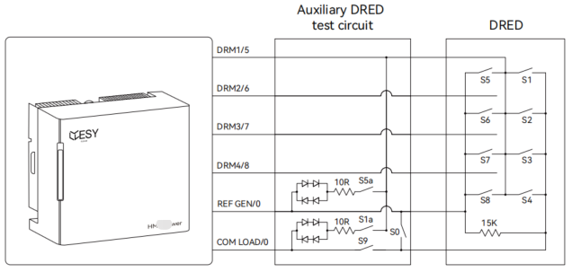

Please refer to the table below for DRM mode explanation. This product is only applicable to DRM0 mode.

|  |  |
| --- | --- |
| Mode | Requirement |
| DRM0 | Operate the disconnection device |
| DRM1 | Do not consume power |
| DRM2 | Do not consume at more than 50% of rate power |
| DRM3 | Do not consume at more than 75% of rate power AND Source reactive power if capable |
| DRM4 | Increase power consumption ( subject to constraints from other active DRMs) |
| DRM5 | Do not generate power |
| DRM6 | Do not generate at more than 50% of rate power |
| DRM7 | Do not generate at more than 75% of rate power AND Sink reactive power if capable |
| DRM8 | Increase power generation ( subject to constraints from other active DRMs) |

## Communication Dongle Connection (Optional)

|  |  |  |
| --- | --- | --- |
| WiFi/Bluetooth Port Connector Pin Definitions | | |
|  | 1 | VCC |
| 2 | GND |
| 3 | Data Communication |
| 4 | Data Communication B |

# System Operation

## Power On

|  |  |
| --- | --- |
|  | **Warning!** |
| Please double-check that the installation to ensure it is correct and reliable before powering on. |
|  | **Warning!** |
| If the backup load, generator, or PV inverter is not installed, do not place the connector into the port. |
|  | **Warning!** |
| Please shield unused ports with waterproof caps. |
|  | **Warning!** |
| After installation, please use the lock key to lock the door. Please take good care of the lock key. |
|  | **Warning!** |
| Please keep the unused connectors and accessories properly. |

When powering on, please adhere to the following steps:

Step 1：Turn on the DC switch of the distribution box.

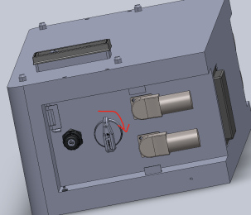

Step 2：Press the power button on the power distribution box and wait for 15 seconds.

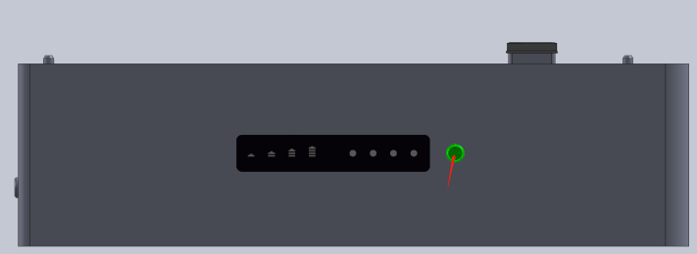

Step 3：Turn on the PV switch of the inverter.

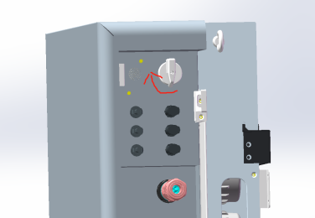

Step 4：Switch the grid breaker to power on.

Step 5：Switch the backup load breaker to power on.

Step 6：If connected to the GED port, activate the generator or PV inverter linked to the GED port.

## Power Off

When powering off, please adhere to the following steps:

Step 1：Turn off the backup load.

Step 2：Turn off the generator or PV inverter connected to the GED port;

Step 3：Turn off the grid port;

Step 4：Turn off the PV Switch on the inverter;

Step 5：Turn off the DC Switch on the distribution box;

Step 6: Press the button on the distribution box to release it.

|  |  |
| --- | --- |
|  | **Warning!** |
| After shutdown, please wait for at least 5 minutes before performing any other maintenance operations on the all-in-one equipment. |

## Precautions

If the inverter is not used for more than 7 days, please disconnect the circuit breakers for the battery, photovoltaic system, grid, and load.

When the system has multiple battery packs, please turn off the DC switches of all battery packs when shutting down the system, and ensure that all buttons on the distribution boxes are in the released state.

After the system has been shut down for more than 7 days, when using it again, the inverter needs to be set to charging mode to charge all batteries to SOC=100%.

After the initial installation of the system, all batteries need to be charged to SOC=100%.

# LED Display Description

## Inverter LED Display

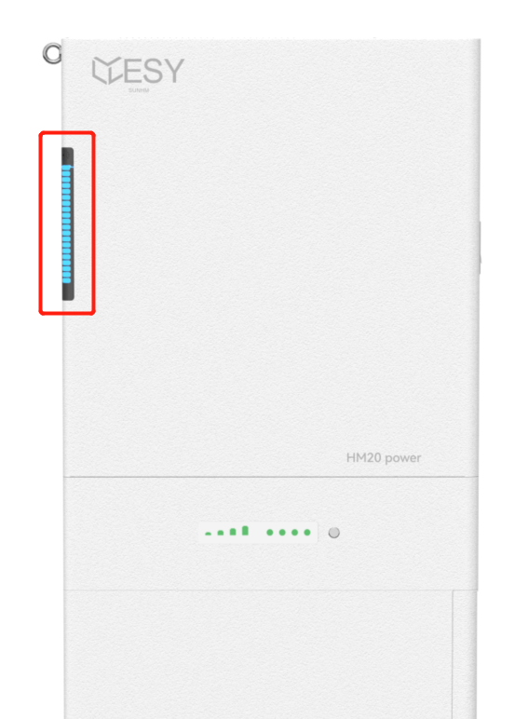

|  |  |
| --- | --- |
| Status | Instruction |
|  | The "Battery" symbol located at the bottom of the light bar signifies the power level. It comprises 20 segments, each representing 5% of electricity. Whenever the power fluctuates by 5%, the light will remain ON for 60 seconds before turning OFF. |
|  | The symbol "Power" at the bottom of the light bar indicates the power level. It consists of 20 segments, each representing 5% of the power. Whenever the power changes by 5%, the corresponding segment will be ON for 60 seconds and then turn OFF. |
| When the indicator at the bottom of the light bar is OFF and the top three indicators are ON, it means that the equipment has an alarm or fault. If the equipment is faulty, please promptly seek assistance from professional personnel to resolve the issue. | |
|  | |

Note：

The inverter employs visual signals (LED lights) to comply with earth fault alarm requirements as per AS/NZS 5033.

The "Earth Fault" alarm is classified as a Level 2 critical alarm. When the inverter is not properly grounded, the top two red indicator lights will remain illuminated. Please ensure proper grounding to resolve the alarm.

This product should be installed in a high-traffic area where the alarm would be easily noticed.

## Distribution Box LED Display

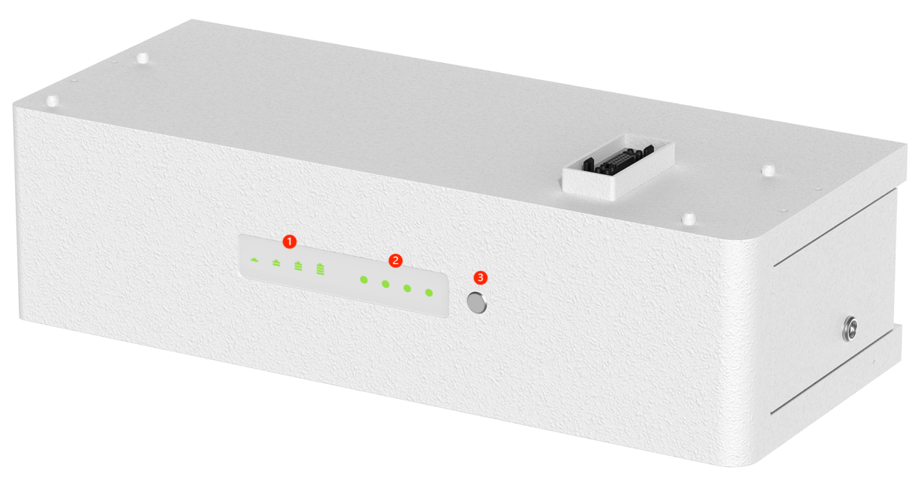

### LED Display Descriptions

|  |  |  |  |  |  |  |  |
| --- | --- | --- | --- | --- | --- | --- | --- |
| LED Display Descriptions | | | | | | | |
| Status 1 | Status 2 | RUN | ALM | SOC Indicator Light | | | |
|  |  | 1 Bar | 2 Bars | 3 Bars | 4 Bars |
| Power off | Sleeping | OFF | OFF | OFF | OFF | OFF | OFF |
| Standby | Normal | Flash | OFF | The display is determined by the Average SOC indicator light status, which represents the average battery level for each battery pack. | | | |
| Warning | Flash | Flash |
| Fault | OFF | Flash |
| Charging | Normal | ON | OFF | The display is determined by the Average SOC indicator light status, which represents the average battery level for each battery pack. | | | |
| Warning | ON | Flash |
| Fault | OFF | ON |
| Discharging | Normal | ON | OFF | The display is determined by the Average SOC indicator light status, which represents the average battery level for each battery pack. | | | |
| Warning | ON | Flash |
| Fault | OFF | ON |
| Maintenance | Updating | Flash | Flash | Flash | | | |

### SOC LED Descriptions

|  |  |  |  |  |  |  |  |  |  |
| --- | --- | --- | --- | --- | --- | --- | --- | --- | --- |
| Average SOC Status Descriptions | | | | | | | | | |
| Status | | Charging | | | | Discharging | | | |
| SOC LED | |  |  |  |  |  |  |  |  |
| Average Battery Level% | 0~25 | Flash | OFF | OFF | OFF | Flash | OFF | OFF | OFF |
| 25~50 | ON | Flash | OFF | OFF | ON | Flash | OFF | OFF |
| 50~75 | ON | ON | Flash | OFF | ON | ON | Flash | OFF |
| 75~100 | ON | ON | ON | Flash | ON | ON | ON | Flash |
| 100 | ON | ON | ON | ON | ON | ON | ON | ON |